JOB POSITION – Bartender
YOUR LOGO HERE

JOB OVERVIEW
The Night Owl group is responsible for the creation and operation of Cold Room, El Pequeño and Parliament. Each venue has its own style and personality that shines through in its service, food and drink offerings and ambience. These venues are in the business of creating new experiences for our guests through the restaurant’s and staff’s personalities. As a bartender, you are involved in delivering fast paced, high volume drinks service; serving our guests a variety of cocktails, beers and wines. Whether it be late night drinks at Cold Room, Daiquiris on the patio at El Pequeño or a pint of guiness at Parliament, bartenders delivers the best experience a guest can have inspired drinks, a vibrant atmosphere and being one of the most progressive hospitality groups in Montreal.

JOB RESPONSIBILITIES
Day Preparation and Service (for El Pequeno and Parliament)
- Day shift preparation including recreating prep recipe to specifications when needed
- Serve and prepare food for guests (El Pequeno)
- Serve guests at bars and at tables
- Assure duties are completed for nightside changeover
- Changeover checklist

Drink Service
- Take beverage orders from guests at bar and serving staff
- Mix liquor, soft drinks, water and other ingredients to prepare cocktails and other drinks in set out time limits
- Prepare mixed drinks, wine, draft or bottled beer and non-alcoholic beverages for servers in set out time limits
- Prepare espresso drinks for the servers in set out time limits
- Wash and polish glassware
- Ensure compliance with provincial liquor legislation and regulations
- Check ID’s to ensure and verify guests age
- Stop service and expulsion of an intoxicated guest
- Help to create new cocktails for features and future menus

Phone Responsibilities
• Answer phone calls and take messages

Training and Sales
• Suggestive up selling of food and beverage through servers
• Train and supervise other bartenders and floor staff
• Support the floor staff with expediting and running food, hosting and bussing tables

Closing Duties and Inventory
• Maintain inventory and control of bar stock and order supplies
• Clean bar area to checklist specs
• Create and post next day duties and prep items on Facebook Group Chat, assuring Bar Captain and Manager know of any immediate issues
• Associated closing duties for the security of the restaurant; front doors locked, awning up, washrooms cleaned

JOB REQUIREMENTS
Must be legal drinking age

EDUCATION
Minimum schooling
• Secondary School English and Math

SPECIAL FORMAL QUALIFICATIONS (not necessary but preferred)
WSET - http://www.wineplus.ca/?portfolio=wine-school
• Classroom style training on the basics of wine, regions and serving
BARSMARTS – www.barsmarts.com
• Online class for spirits, cocktail and service knowledge

EXPERIENCE
High volume, fast paced restaurant and bar experience. Average to above average knowledge of beer, wine, spirits and cocktails. Espresso or Barista training will be highly regarded.

NUMBER OF YEARS
Two years recent, (in the last 5 years) full-time experience

WORKING CONDITIONS
- Constant standing and walking throughout shift
- Working alone in a busy environment
- Singly running the bar throughout shift
- Rigorous and constantly moving in a small, confined bar area
- Occasional lifting and carrying up to 20 lbs
- Changing kegs
- Transporting cases of wine/beer
- Changing chemicals in dishwasher
- Occasional kneeling, pushing, pulling, lifting
- Occasional ascending or descending ladders, stairs and ramps
- A busy, high stress environment that requires quick decision making
- Possibility of having to attend and deal with intoxicated people and other disturbances

EQUIPMENT
- POS;
- Knives – Bar knife, bread cutting knife
- Espresso Machine – group head and steam wand
- Glasswasher – chemical changing and close cleaning
- Freezer – Ice and glassware storage

KNOWLEDGE
- Product knowledge
  - Wine List
    - Wine pairing for food and guests flavor profiles
  - Spirits List
    - Recommend spirits for drinking neat and in cocktails
  - Beer List – Small but focussed list featuring local and international beer
    - Recommend beers comparable to guests’ preference
  - Cocktail List – Elevated, modernist style cocktails along with classics
    - Recommend cocktails comparable to guests’ preference
  - Espresso
    - Creating classic espresso drinks such as cappuccinos and lattes
- Knowledge of relevant laws and regulations
- Hospitality industry knowledge
- Knowledge of Silverware Point of Sale

SKILLS
- Customer relations skills
- Cash handling experience
- Clear, precise, professional and helpful manner
- Excellent organizational skills with the proven ability to perform well with minimal supervision
- Good listening skills
- Effective Oral communication
ABILITIES
- Self supervising and learning
- Teamwork and cooperation
- Ability to multi-task
- A high level of responsibility and commitment with proven success in relationship building
- Conflict resolution between customers and staff
- Commitment to provide excellent service and exceed guests' expectations
- Professional appearance and attitude
- Impeccable grooming and presentation
- Shows good judgement and common sense
- Flexible and adaptable during busy shifts that change day to day

SUPERVISION and DECISION MAKING
This role is self-supervised. We empower and train our staff to work as a team but also alone. Bartenders are required to make decisions based on the staff matrix on how to maximize the guest experience. These include;
- Allergies and Dietary Restrictions
    - Responsibility to understand the ingredients in dishes to ensure that no guest has an allergic reaction or gastro imbalance.
Failure to do so could lead to anaphylactic shock, nausea and vomiting.
- Discounts
    - Direct responsibility of addition of discounts to bills to ensure guest satisfaction through “reading the table” and identifying a less than stellar experience.
Everyone that dines at Pagliacci’s deserves the best experience possible, not delivering this through discounting necessary dishes or drinks could lead to bad reviews online; something taken very seriously.
- Closing Duties
    - Check that front doors are locked
    - Check that washrooms are clean
    - Check to assure the debit machines are on charge
    - Check to assure the front awning is up
Lack of completing Closing Duties will result in possible theft and vandalism, imposing on the opening team and cash outs.

CONTACTS
Company Representatives – liaison with spirit, wine and beer representatives; gathering information and passing it on to the bar manager.

RESPONSIBILITY FOR RECORDS
Cash Float – Counting, balancing and recording cash float at beginning and end of your shift.
Cash Summary – Balancing and remitting the correct amount for shift sales
Tips – Correctly calculating and splitting tips
Log Book – Creating a log book post listing out of stock items, required prep, tapped kegs and any other notes for the next shifts bartender. This listing must be posted on the group Facebook Chat.

ORGANISATIONAL FLOW CHART
As a bartender, you immediately answer to the Bar Captain on duty, then the Bar Manager for El Pequeño Bar
and Cold Room and finally the Venue Manager of El Pequeno and Cold Room.

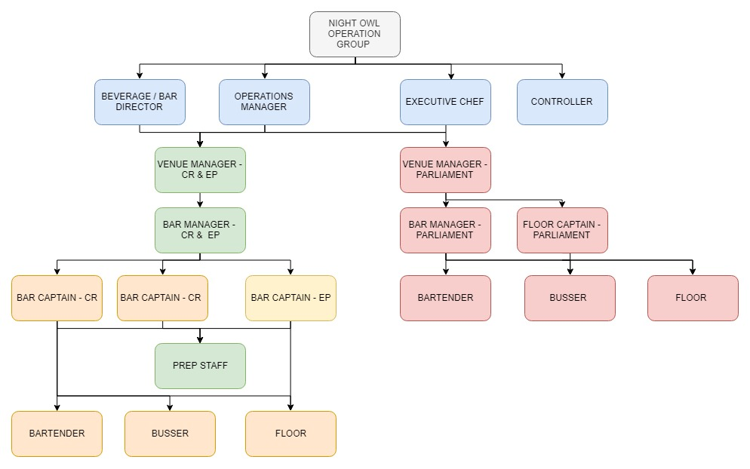

PACKAGE INCLUDING PAY RATE AND BENEFITS
Pay Rate –
Benefits –

SIGNATURES:

_______________________________________________________________________________________________________
Staff Member
Bartender Candidate Bar Manager Beverage Manager
DATE:_ ____________________________________________________________________________________________
Position: Bartender – Full time

As one of Singapore’s newest restaurants, Miss Fitz is in the business of creating new experiences for our guests through the restaurant’s and staff’s personalities. As a bartender, you are involved in delivering fast paced, high volume restaurant service; serving our guests our Mediterranean inspired cuisine complimented by our wine and bar program. Miss Fitz delivers the best experience a guest can have through casual fine dining, a vibrant atmosphere and being one of the newest concepts in the city.

We are currently recruiting for the position of bartender in our restaurant. The hours for this role are approximately 40 hours per week.

EXPERIENCE
High volume, fast paced restaurant and bar experience. Average to above average knowledge of beer, wine, spirits and cocktails. Espresso or Barista training will be highly regarded.

NUMBER OF YEARS
Two years recent, (in the last 5 years) full-time experience.

SUMMARY OF JOB RESPONSIBILITIES
Reporting to the Supervisors and Managers, responsibilities and essential job functions include but are not limited to the following:
- Recreating prep recipe to specifications
- Take beverage orders from serving staff
- Mix liquor, soft drinks, water and other ingredients to prepare cocktails and other drinks
- Prepare mixed drinks, wine, draft or bottled beer and non-alcoholic beverages
- Prepare espresso drinks
- Wash and polish glassware
- Suggestive up selling of food and beverage through servers
- Train and supervise other bartenders and floor staff
- Support the floor staff with expediting and running food, hosting and bussing tables
- Maintain inventory and control of bar stock and order supplies
- Clean bar area
- Associated closing duties for the security of the restaurant.

QUALIFICATIONS REQUIRED
- Must be legal drinking age
- Knowledge of relevant laws and regulations
- Customer relations skills
- Cash handling experience
- Excellent organizational skills with the proven ability to perform well with minimal supervision
- Good listening skills
- Effective Oral communication
- Self supervising and learning
- Ability to multi-task
- Professional appearance, attitude, impeccable grooming and presentation
- High School Graduate - Secondary School English and Math
- WSET (Wine and Spirits Education Trust) Certificates is highly regarded
- BarSmarts is highly regarded

WORKING CONDITIONS
- Constant standing and walking throughout shift
- Singly running the bar throughout shift
- Occasional lifting and carrying up to 20 lbs
- Occasional kneeling, pushing, pulling, lifting
- Occasional ascending or descending ladders, stairs and ramps
- A busy, high stress environment that requires quick decision making

The Miss Fitz Bar Team demonstrates a daily commitment to excellence by providing professional and memorable experiences that put people first.

We thank all applicants in advance however please note only those chosen for an interview will be contacted.

Job Type: Part-time

Salary: Starts at $12.50/hour plus tips

YOUR LOGO
BARTENDER / SERVER SCREENING CHART
Applicant Name - ______________________________________
Date Applied - _________________________________________
- Assign presented points to each qualification
- Total points at the end of each section
- Continue to next section if required points target are attained

STAGE 1 - Minimum Required Qualifications
Each qualification is graded at one point, for stage 1; all qualifications must be achieved.

MINIMUM REQUIRED QUALIFICATIONS | POINTS
Legal drinking age
High school graduation
Serving It Right
Food Safe
Two years recent (in the last 5 years) full-time experience as a bartender
TOTAL | /5

STAGE 2 - Essential Qualifications
Essential Qualifications – applicant must score at least 16/32 to progress to next stage.

ESSENTIAL QUALIFICATIONS | FAILS (0 points) | MEETS (1 point) | EXCEEDS  (2 points)
Experience with POS systems
Knowledge of relevant laws and regulations
Hospitality industry knowledge
Basic Wine Knowledge & Experience
Basic Spirit Knowledge & Experience
Basic Beer Knowledge & Experience
Basic Cocktail Knowledge & Skills
Basics Espresso Knowledge & Skills
Customer relations skills
Cash handling experience
Excellent organizational skills
Self supervising and learning
Ability to multi-task
ESSENTIAL QUALIFICATIONS cont. | FAILS (0 points) | MEETS (1 point) | EXCEEDS  (2 points)
Conflict resolution
Provides excellent service and exceed guests' expectations
Flexible and adaptable during busy shifts that change day to day
TOTAL | /32

STAGE 3 – Preferred Qualifications
Preferred Qualifications – applicant must score at least 9/18, points to be tallied and interview to be set if minimums are acquired.

PREFERRED QUALIFICATIONS | FAILS (0 points) | MEETS (1 point) | EXCEEDS  (2 points)
Advanced Wine Knowledge & Experience*
Advanced Spirit Knowledge & Experience*
Advanced Beer Knowledge & Experience*
Advanced Cocktail Knowledge & Skills*
Advanced Espresso Knowledge & Skills*
WSET / ISG Training¹
BarSmarts²
CSS³
First Aid
TOTAL | /18

¹ WSET / ISG – Wine and Spirit Education Trust / International Sommeliers Guild
² BarSmarts Online Training Course
³ CSS – Certified Spirits Specialist
* Must have basic skill set to gain point in this stage

STAGES | POINTS
Minimum Required Qualifications | /5
Essential Qualifications | /36
Preferred Qualifications | /18
TOTAL | /59⁴

Proceed to Interview - YES NO FUTURE POSSIBILITY ⁵

Interview to be scheduled - _____________________________________________________________________________________

By - ____________________________________________________________________________________________________________

⁴ Minimum of 21 points to acquire to gain interview.
⁵ Possibility of employment in a similar or lesser role in the future. Track bartending career and training.

YOUR LOGO HERE
BARTENDERS INTERVIEWING CHECKLIST
Applicant Name - __________________________________________
Date of Interview - _________________________________________

STAGE ONE – INTERVIEW QUESTIONS
How many years have you been bartending? ___________________________________________________________________
What do you know about Pagliacci’s?
Pagliacci’s is a family owned restaurant, open for almost 40 years. Cuisine is New York Italian with big portions of pasta, endless bread and slabs of cheesecake.
__________________________________________________________________________________________________________________________________________________________________________________________________
What has been your favorite aspect of working in this industry? _________________________________________________________________________________________________________________________________________________________________________________________________
What was your favorite workplace? Why? __________________________________________________________________________________________________________________________________________________________________________________________________
What is your favorite wine and where is it from? Winery name (1), wine style & varietal (2) region (1) and why (1).
1 point for each category, out of five (5).
E.g. Nagging Doubt “The Pull”, a Bordeaux style blend from the Okanagan that has a label created by a famous chalk board artist showing all the details about the wine and flavours. ______________________________________________________________________________________________________________________________________________________________________________________________________________________( / 4)

Tell me a time that you exceeded a guest’s experience? Who, what, where, how and why?
E.g. A guest was curious about our amaro section and I asked what they had tried in the past, they said only a few simple ones; I suggested Amaro Montenegro from Bologna. She said, “that would be perfect”, I sent out a flight of comparative amari so that she could experience more than just the Montenegro. She was grateful and now returns every Saturday to order more. __________________________________________________________________________________________________________________________________________________________________________________________________
What’s favorite cocktail bar in Victoria? What’s your favorite cocktail there? Where (1), cocktail (1) and why (1).
1 point for each category, out of three (3).
E.g., Veneto Lounge, Tango till They’re Sore, a milk punch cocktail created to homage Foxtrot Tango Whisky Bar.
___________________________________________________________________________________________________________________________________________________________________________________________ ( /3)
What is your favorite local brewery and beer? Which brewery (1), which beer (1) and style (1) and why (1).
1 point for each category, out of four (4).
E.g. Driftwood Brewery, Raised by Wolves IPA seasonal; it’s a wild ferment IPA, I love wild fermented beers and love IPA’s so best of both worlds.
___________________________________________________________________________________________________________________________________________________________________________________________ ( /4)
What is your favorite spirit? Style (1), Brand (1) why (1).
1 point for each category, out of three (3).
E.g. My favorite spirit would be Del Maguey Chichicapa Mezcal because it was the first time, I truly fell in love with mezcal in my career.
__________________________________________________________________________________________________________________________________________________________________________________________ ( /3)

STAGE TWO – ONLINE QUIZ
Pagliacci’s Bartender Quiz - https://www.surveymonkey.com/r/5DGCR56

STAGE THREE – ASSESSMENT
ASSESSMENT | TOTAL
Graded Questions | /14
Pagliacci’s Bartender Quiz | %
Overall Assessment | /10

INTERVIEW RUBRICS
Grade Questions – 10/14, pass mark
Pagliacci’s Bartender Quiz – 80% pass mark
Overall Assessment – Professional appearance and attitude, punctuality, clear and punctual.
0-3 – Late, dressed inappropriately, poor attitude, answered questions vaguely
3-6 – Punctual but lacked attitude, attire, attention, answered questions averagely response to quiz was negative
6-10 – Punctual, dressed appropriately, keen attitude, curious about restaurant, answered questions in-depth and concise, overall reflected restaurants mantra

STAGE FOUR – REFERENCE CHECKS
Name, Title, Phone Number, Brief Overview of Reference ______________________________________________________________________________________________________________________________________________________________________________________________________________________________
Name, Title, Phone Number, Brief Overview of Reference ______________________________________________________________________________________________________________________________________________________________________________________________________________________________
STAGE FIVE – FINAL DECISION
HIRE - YES NO

Hired by ________________________________________________________
General Manager Sign Off _______________________________________
Start Date ______________________________________________________

